DISASTER PLANNING

BOARD WORKSHOP

Kings Point / May 18th, 2023 / Veterans Theater
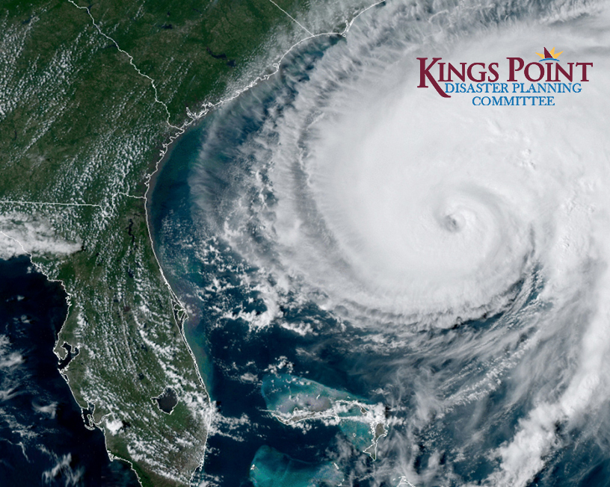
WWW.KPMASTER.COM/DISASTERPLANNING

This guide is intended to help you prepare for a hurricane and deal with the aftermath.
THIS GUIDE IS NOT INTENDED TO BE ALL-INCLUSIVE.

TABLE OF CONTENTS
Emergency Preparedness Plan…………………1-2
Board Emergency Powers…………………………3-4
Expectations…………………………………………...5-7
Clean-Up…………………………………………………8-9
Evacuation & Floods……………………………10-12
Hurricane Watch & Warnings……………………13
Should I Stay or Should I Go?........................14
After the Storm…………………………………………15
Important Things to Know…………………….16-18
Resources……………………………………………19-32
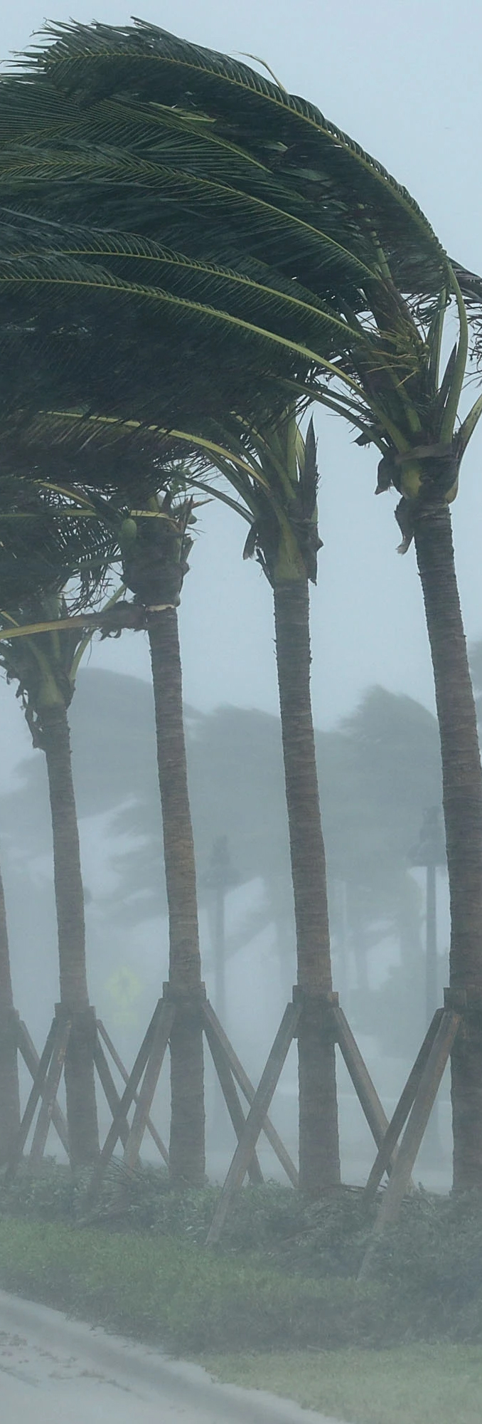

emergency prepardness plan

Why do Associations need to have an Emergency Preparedness Plan?
It is part of the Association’s duty to protect the well-being of their community and act in the best interest of their residents. Although having a Hurricane Preparedness Plan will certainly not save your community from being hit by a hurricane, it will assist your association and residents to be prepared when the time comes. Ultimately, having a plan will help minimize health, safety, and monetary risks for the entire community.

What should be included in my Association’s Emergency Plan?
A well-crafted COA/HOA emergency plan consists of the following items:
- CHAIN OF COMMAND
Every plan requires a chain of command — an organizational structure that tells you who is in charge of what. This chart should obviously have a leader, which is a role usually fulfilled by the board president. The president should serve as the first point of contact, with the Association manager closely following in second place. Someone should also be in charge of communications.
- SITE PLAN
A good emergency plan should also consist of a site plan for the whole association. This site plan must highlight and label important areas of the neighborhood, including but not limited to shut-off valves, lift stations, debris staging areas, and generators. Shut-off valves, in particular, should be a priority when an emergency occurs. Getting to these valves will allow you to prevent leaks and reduce the potential for damage.
- EVACUATION PLAN
One of the most critical items in a COA/HOA emergency plan is the evacuation plan. The evacuation plan must consist of guidelines and a map for evacuation. Using this plan, residents will know the proper way to evacuate the premises.

- STANDARD PROCEDURES
An association plan serves as a guide for everyone in the community during times of uncertainty. Thus, it should contain standard procedures for various circumstances. If the utilities shut off, what must residents do? What if some buildings and homes become condemned? Identify all possible disaster outcomes and outline the steps the association and its residents must take in the event of each one.

- INSURANCE
Because emergencies can happen at any moment, you need to have all the essential documents with you in one place. Some of the most crucial documents you should have are copies of your insurance policies. Make sure to also include instructions on how you can file claims as well as the contact information of your insurance provider.

- PHOTOS OF THE COMMUNITY
Keeping photos of the community’s properties, equipment, and components will come in handy for insurance purposes and for when you need to restore them back to their original form. Make sure to take updated photos of the community, too. A camera with a date stamp is also recommended.
- DESIGNATED MEETING PLACE
Confusion and panic are common feelings residents will experience during a crisis. To help mitigate such feelings, your plan should include a designated meeting place amidst the commotion. This is where can proceed after an emergency occurs. Assigning a meeting place will also allow you to have a standard area where you can give important community updates.

- ESSENTIAL CONTACT DETAILS
A list of all essential contact information should naturally make it into your emergency kit. This list should include the contact details of all board members, your CAM, your attorney, and your insurance provider, as well as all vendors or contractors. You should also have contact and emergency contact information from your residents. Residents should be encouraged to inform the Board if they plan to shelter in place or evacuate.

- DEBRIS MANAGEMENT AND REMOVAL
In case your community suffers a disaster that results in scattered debris, you must know how to handle them. Therefore, your emergency plan should include instructions for debris management and removal.

- RESPONSE PLAN
Apart from pre-emergency and mid-emergency plans, you must also come up with a post-emergency plan. First, make sure everyone in your community is safe. Then, you must move on to evaluate the damage to your neighborhood. You will need the help of professionals to inspect and evaluate the level of damage.
Some disasters will render homes uninhabitable. To make sure residents can return to their homes, you may need to talk to local authorities and safety professionals. During this time, your association will need to ask for residents’ cooperation and understanding as they may not be able to immediately return to their homes due to safety concerns.

If you would like individual assistance in developing your Association’s Emergency Plan from the Disaster Planning Committee, please contact the Committee Chair, MaryAnn Meeker at mmeeker3@tampabay.rr.com to schedule an appointment.

board emergency powers

DID YOU KNOW?
Certain emergency situations may call for a rapid response and thorough preparation from the HOA or COA in order to safeguard the wellbeing of the community. To this end, an Association’s ordinary powers can sometimes be expanded during times of emergency. These expanded powers are typically referred to as “emergency powers,” and can serve as a key source of guidance and leadership during crises.
The authority of HOAs and COAs to enforce their rules and regulations is rooted in statutory authority. Chapter 720 of the Florida Statutes empowers and controls the ability of HOAs to enforce their rules in Florida, whereas Chapter 718 of the Florida Statutes empowers and controls the ability of COAs to enforce their rules in Florida. In regard to the issue of emergency powers for HOAs and COAs, Florida Statute 720.316 provides guidance as to HOAs, while Florida Statute 718.1265 sheds light on powers for COAs.
As to emergency powers for COAs, Florida Statute 718.1265 states, in summary:
To the extent allowed by law, unless specifically prohibited by the declaration of condominium, the articles, or the bylaws of an association, and consistent with s. 617.0830, the board of administration, in response to damage or injury caused by or anticipated in connection with an emergency, as defined in s. 252.34(4), for which a state of emergency is declared pursuant to s. 252.36 in the locale in which the condominium is located, may exercise the following powers:
- Conduct board meetings, committee meetings, elections, and membership meetings, in whole or in part, by telephone, real-time videoconferencing, or similar real-time electronic or video communication with notice given as is practicable.
- Cancel and reschedule any association meeting.
- Name assistant officers (persons who are not directors) that can act as an executive officer as a fill in to assist in the absence or unavailability of an officer.
- Relocate the association’s principal office or designate alternative principal offices.
- Enter into agreements with local counties and municipalities to assist counties and municipalities with debris removal.

- Implement a disaster plan or an emergency plan before, during, or following the event for which a state of emergency is declared which may include, but is not limited to, shutting down or off elevators; electricity; water, sewer, or security systems; or air conditioners.
- Based upon advice of emergency management officials or public health officials, or upon the advice of licensed professionals retained by or otherwise available to the board, determine any portion of the condominium property or association property unavailable for entry or occupancy by unit owners, family members, tenants, guests, agents, or invitees to protect the health, safety, or welfare of such persons.
- Require the evacuation of the condominium property in the event of a mandatory evacuation order in the locale in which the condominium is located.
- Based upon advice of emergency management officials or public health officials, or upon the advice of licensed professionals retained by or otherwise available to the board, determine whether the condominium property, association property, or any portion thereof can be safely inhabited, accessed, or occupied.
- Mitigate further damage, injury, or contagion, including taking action to contract for the removal of debris and to prevent or mitigate the spread of fungus or contagion, including, but not limited to, mold or mildew, by removing and disposing of wet drywall, insulation, carpet, cabinetry, or other fixtures on or within the condominium property.
- Contract, on behalf of any unit owner or owners, for items or services for which the owners are otherwise individually responsible, but which are necessary to prevent further injury, contagion, or damage to the condominium property or association property.
- Regardless of any provision to the contrary and even if such authority does not specifically appear in the declaration of condominium, articles, or bylaws of the association, levy special assessments without a vote of the owners.
- Without unit owners’ approval, borrow money and pledge association assets as collateral to fund emergency repairs and carry out the duties of the association when operating funds are insufficient.
As such, it should be noted that the emergency powers of an HOA or COA are limited, and the extent to which an HOA or COA can exercise these powers are always dependent on its governing documents, state law, and the nature of the emergency. Boards should also take into account that any emergency powers utilized by an HOA or COA Board must be exercised in a manner consistent with the board’s fiduciary duty to the community. An Association Board should be careful to balance its obligation to protect and look to the best interests of the community along with the limitations of its authority.

EXPECTATIONS

WHAT SHOULD RESIDENTS EXPECT FROM THEIR ASSOCIATION BOARD?
Communication in advance of the storm
- Evacuation monitoring
- Shelter locations
- Other reminders
Help the Board account for your whereabouts…although ultimately, you are responsible for the safety of yourself; the Board is not
- FSR will provide a headcount checklist
To be told to secure outdoor objects to protect property
- Note the Association has the right to throw out any items you fail to secure
That damage will be addressed as soon as possible
- The Association will follow proper procedures with FirstService regarding damages
- The Association should designate a Board Member or POC to act as a disaster point of contact in times of emergency and instruct residents to report all damages in the Association to that person.
- The designated emergency POC should compile all damages into one email and send it to Steve Knott with FirstService Residential at steve.knott@fsresidential.com
That Boards will be financially prudent in the recovery and/or restoration of property damage and in the potential assessments for losses.

The Board will be responsible for Common Areas/Elements ONLY.

The Board should review their documents and rules to determine procedures for hurricane shutters.

WHAT SHOULD THE BOARD EXPECT FROM THEIR RESIDENTS?
Attention to advance communication regarding the storm
Self-accountability for whereabouts so Board can perform a “headcount”

Cooperation when asked to secure outdoor objects to protect property

To help report damage after the storm to the Board/POC’s

To evaluate loss assessment insurance coverage to minimize financial burdens
To secure their Unit interiors and Limited Common Elements
- Take pictures of unit interiors and keep for post storm claims
- Take pictures of unit exteriors and keep for post storm claims

WHAT TO EXPECT FROM FIRSTSERVICE RESIDENTIAL?
FirstService’s goal is to protect the lives and health of residents and the employees of Kings Point and protect and minimize damage to residents’ property in the event of an emergency.

Priorities
- To evacuate and account for all employees.
- To assemble the company’s Emergency Response Team for implementation of the response plan as soon as it is safe to do so.
- Prevent further property damage through mobilizing vendors to begin repairs and estimates as soon as it is safe to do so.
- File any applicable reports with the Federation of Kings Point.

Emergency Response Procedure
- Assess the situation, number and types of hazards expected based on experience.
- Protect residents, employees, contractors, equipment, vital records and other assets.
- Coordinate with the insurance company on any possible claims.
- Get the community back up and running.

Miscellaneous
- Financial – FSR Emergency Loan Fund – available to bridge gaps for repairs while waiting for insurance.
- FEMA – FSR will assist in FEMA aid applications if applicable
- Hurricane Shutters – Each Association Board should review their documents and rules to determine procedures for hurricane shutters, if applicable

WHAT TO EXPECT FROM VESTA & SECURITY?
In the event of a Natural disaster, Vesta will close and secure the Land Trust properties including pools, clubhouses, and recreation areas as directed by the federation board. Gate House security will remain in place until winds reach 35mph, and/or the Hillsborough County Sheriff’s office directs closure of this operation. After the event has ended, representatives of Vesta and other local authorities will assess the damage to Trust properties and in partnership with the Federation board will open the amenities when it is safe to do so.

WHAT TO EXPECT FROM THE MASTER ASSOCIATION?
The Master Association’s goal is to help minimize safety and monetary risks for the entire community with regards to infrastructure and roadways.
- Conduct regular inspections of our roads, bridges, drainage structures and landscaping to identify and mitigate any potential safety hazards in advance of a storm.
- Provide designated staging areas throughout the property for the Section Landscapers and restoration vendors to use for landscape and construction debris
- Provide designated staging areas for FEMA, if applicable.
- Assist local officials and FEMA as needed
- Once a watch is issued, a visual inspection of the property will take place.
  - Any fallen branches or debris will be picked up
  - Loose articles and debris will be removed from lake outfalls
  - Obstructions will be cleared from storm drains along Master roadways
  - The irrigation yard will be secured, and all pumps and controllers will be turned off
- Have a manager onsite as soon as it safe to do so after the storm to assess damage and coordinate clean-up
- Contracted with Russell Landscaping for priority landscaping services after the storm
- Contracted with Global Engineering for priority service with our drainage infrastructure

CLEAN-UP

How will Natural Storm Debris Clean Up be handled in your Association?
Grounds Clean Up Fund:

- The Federation budgets $50,000 yearly for the clean-up of Associations natural debris due to a named storm and $50,000 for landscape replacement/clean-up contingency, for a total of $100,000. Fund is not replenished after each event during the same budget year i.e. multiple hurricanes.

Clean Up Responsibilities:

- The Federation contracts separately for hurricane clean up services from the four landscapers, DTE, Artistree, Brightview and Russell’s. The $100,000 is used to pay for the debris clean up. Clean up costs in excess may be billed back to the Association.

Downed Trees & Limbs:

- The cost of tree service following a hurricane is solely borne by the Association. In the event of widespread tree damage, priority will be given first to access, safety, and structure damage mitigation. Associations may be asked to adopt an Emergency Spending policy granting FSR access to and power to expend funds on behalf of the Association for these purposes.
- Associations should consider delegating authority to FirstService Residential’s Specialists to authorize Brown’s Tree Service to remove critical downed branches/trees from their Association

How will Artificial Storm Debris Clean Up be handled in your Association?

Assess & Report
- Board’s & POC’s, when safe to do so, canvass the Association and assess damage done to structures. Log all damage no matter how big or small on the FSR damage report form. Return the form to your FSR CAM ASAP. DON’T discard materials, but make sure they are in an area that won’t cause further damage if possible.

Insurance Process
- Your FSR CAM may view the property damage with you and determine if a claim is worth filing. The deductible is 5% of the value of the structure so damage must be significant to be filed. Significant property damage will first need to be inspected by an insurance claims field adjuster. Your CAM will work with you and the adjuster (if applicable) on claims, material removal, and repairs.

Unit Owner HO-6
- Each unit owner is required by statute to have a minimum of $2,000 in loss assessment coverage in their HO-6 policy. (But unit owners aren’t required to be insured). Unit owner coverage may be significantly under-insured due to a) choice and/or b) newly appraised higher building values. Unit owners can consult with their agent, and the Board and FSR has the building values to determine assessment maximums.

Federation Insurance Deductible Fund:
- Does not apply to hurricane deductibles.

Acadia I, II  Bedford A-J  Fairfield A-H  Inverness  Jameson  Portsmith  Princeton  Lancaster I, II, III, IV  Lyndhurst | Brookfield  Corinth  Devonshire  Highgate A-F, II, III, IV  Nantucket I-V  Radison I, II  Oxford I, II  Idlewood  Worthington | Andover A-I  Cambridge A-M  Canton Court D  Kensington  Maplewood  Oakley Green  Manchester I, II, III, IV  Southampton I, II  Tremont I, II | Dorchester A-D  Edinburgh  Fairbourne  Grantham  Huntington  Gloucester A-P  Knolls I, II, III  Villeroy

Evacuation Vs. FLOOD ZONE
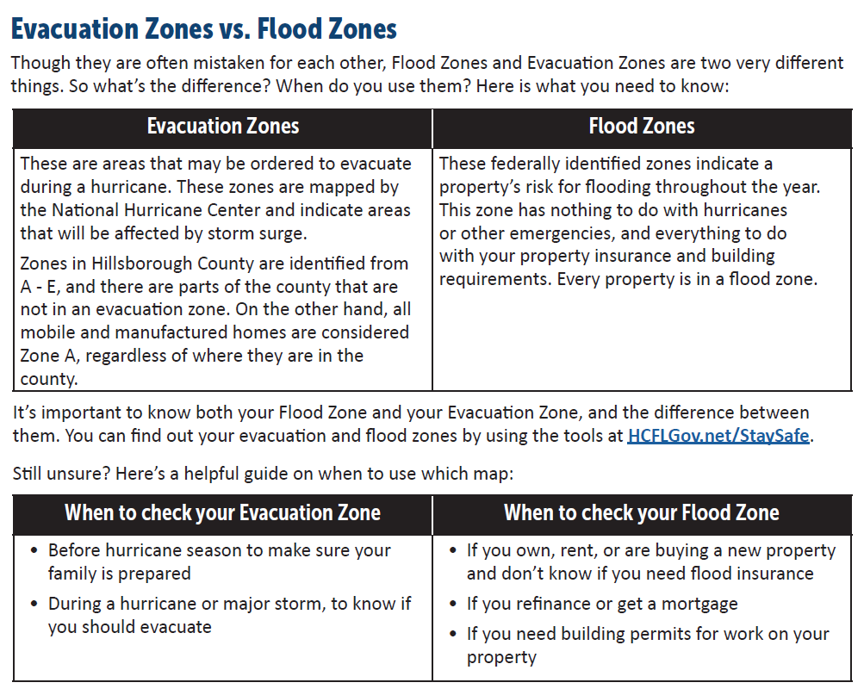
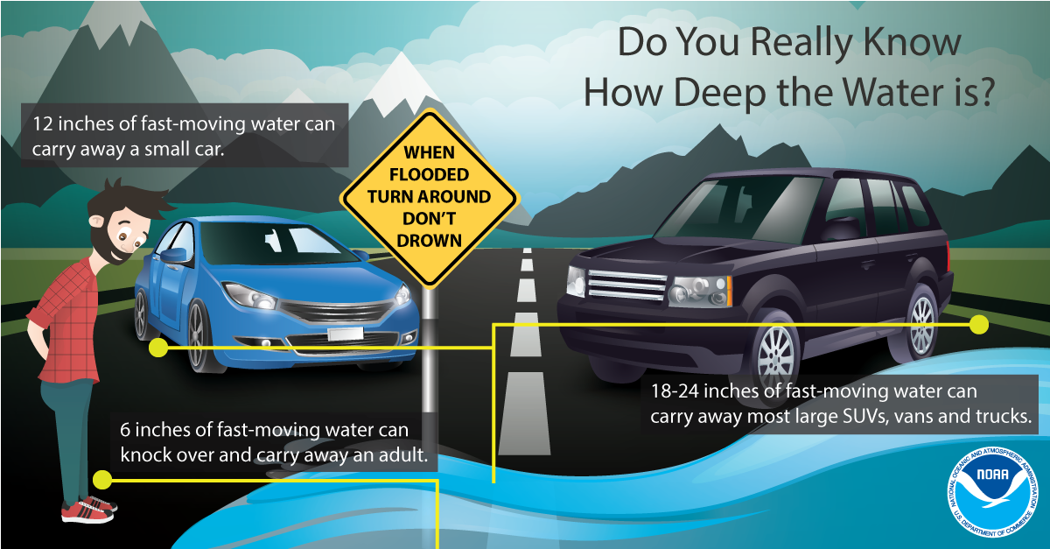

KNOW YOUR ZONES
In an emergency, local officials will order evacuations using zones to keep your family safe. These zones highlight areas most at risk of impacts from hurricanes, tropical storms, and other hazards.

Hillsborough County Evacuation Zone Map (2023) – Kings Point

A small portion of Kings Point is in Evacuation Zone D (Winds at 131 to 155 MPH with potential tide heights to 31’). With that said, a majority of Kings Point is in Evacuation Zone E (Winds at 156 with potential tide heights to 38’).

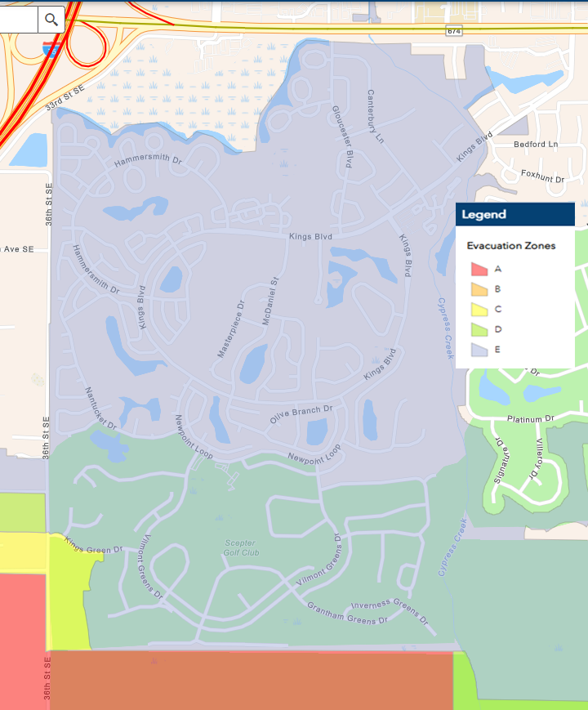
For detailed maps for your specific location, visit www.hillsboroughcounty.org and search for Flood or Evacuation Map

Hillsborough County Flood Zone Map (2023) – Kings Point

Moderate to Low-Risk Areas
Zone X - Floodplain area with a 0.2% (or 1 in 500 chance) or less annual chance of flooding. Includes areas of moderate flood hazard, such as base floodplains and shallow flooding areas, and minimal flood hazard, which may still have ponding and local drainage problems.

High Risk Areas (Special Flood Hazard Area)
Zone A - 100-year floodplain, areas with a 1% annual chance of flooding and a 26% chance of flooding over the life of a 30‐year mortgage. Because detailed analyses are not performed for such areas, no base flood elevations are shown.
Zone AE - 100-year floodplain, the base floodplain where base flood elevations are provided.

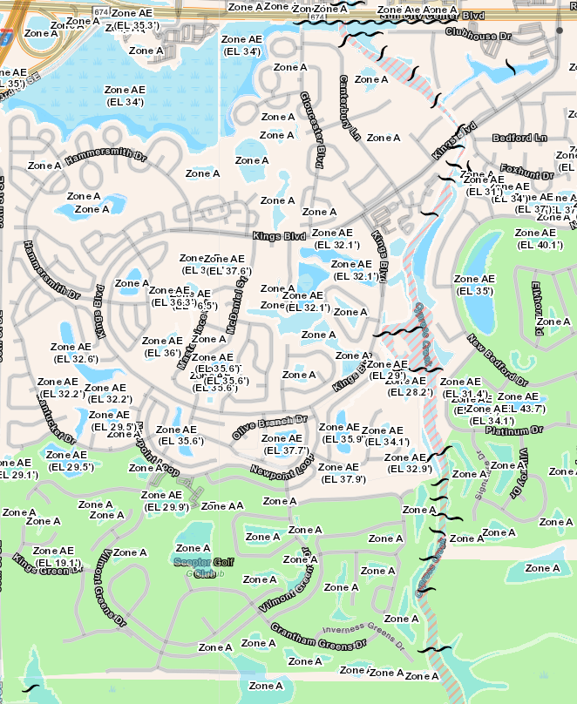

Hurricane Watch Vs warning
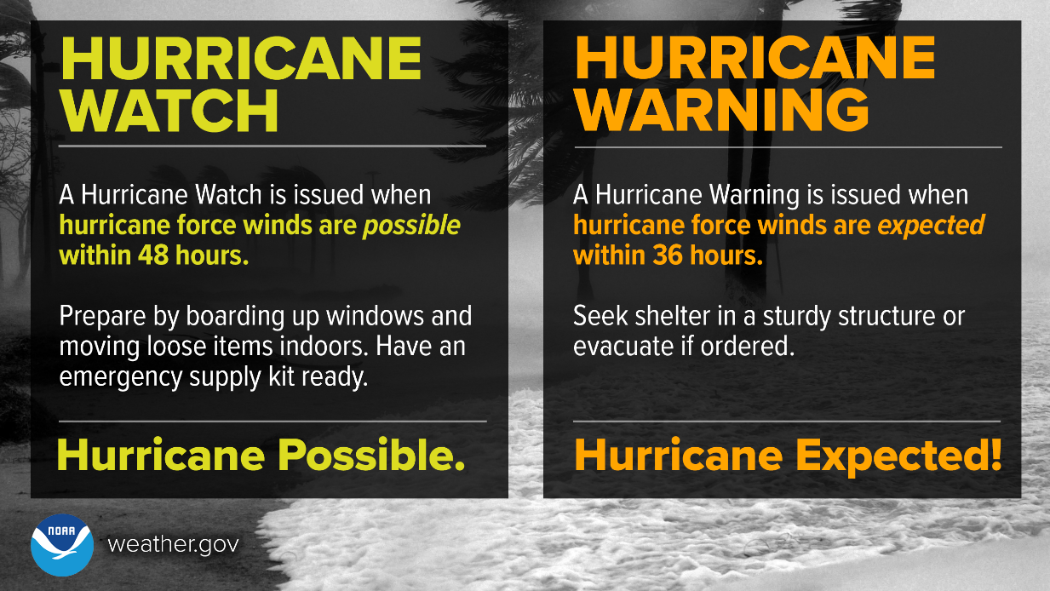

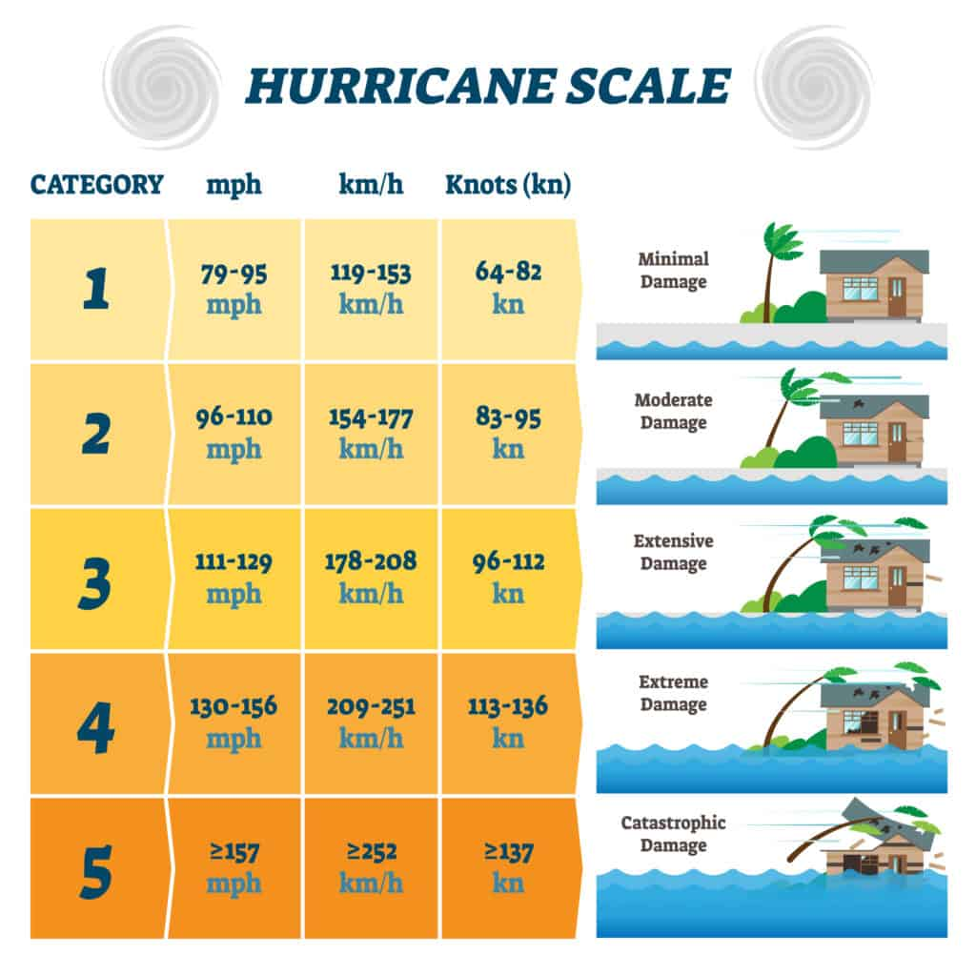

SHOULD I STAY OR SHOULD I GO?
The most critical decision you can make during a hurricane to whether to shelter in place or evacuate. Having a plan means knowing when you safely stay and when it’s time to go.

If You Shelter in Place: | If You Plan to Evacuate:
- Develop a personal disaster plan  - Stay alert to storm advisories  - Purchase a NOAA weather radio  - Consider purchasing a two-way radio from the KP Radio Club  - Keep a Disaster Supply Kit ready  - Have enough food and water for at least 3 days  - Protect your valuable documents  - Bring in loose yard objects  - If you do not have hurricane resistant windows, consider boarding them up  - Get cash as ATMs and banks could be closed for several days  - Fill your care with gas  - Have a plan for your pets  - DO NOT use candles or open flames as a light source  - Once the storm hits, get to an interior room with no windows  - Notify your Association, friends and family of your plans  - LISTEN TO YOUR LOCAL OFFCIALS | - Develop a personal disaster plan  - Stay alert to storm advisories  - Map out your route in advance. DO NOT get on the road without a place to go.  - If you are booking a hotel, do so before you leave  - Going to a shelter should be the last resort.  - Once shelters are opened, Evacuation assistance is available with HART: gohart.org  - Fill your car with gasoline. Prepare for long lines and outages  - Get cash as ATMs and banks could be closed for several days  - Have a plan for your pets  - Bring your disaster supply kit with you  - Secure your important documents and valuables and bring them with you  - Secure your home before leaving  - Notify your Association, friends and family of your plans  - LISTEN TO YOUR LOCAL OFFCIALS

AFTER THE STORM
It could be weeks before roads are safe to open. It could also be weeks before grocery stores and other basic services are restored. Stay informed. Wait until local authorities say it is safe to return or venture out on the roads.

- If you evacuated, enter your home with caution

- Don’t drive in flooded areas

- Open windows and doors to ventilate and dry your home

- Turn off the power to your house if it is flooded. Wait for an electrician to check your home before restoring power

- Keep away from flooded and debris laden areas

- Don’t touch any tree or object in contact with or near power line

- DO call the police or TECO immediately to report hazards such as downed power lines

- DO NOT call to report interruptions in electric, water or phone services. Utilities have a plan for complete restoration of service as soon as possible.

- Check food for spoilage after power is restored. If in doubt, throw it out

- While the power is out, do not use candles.

- Beware of snakes, insects and other animals driven to higher ground by floodwater

- Keep portable gasoline equipment and gas grills at least 20’ from any window, door or vent

- If you use a portable generator, read and follow all instructions and use safely outside far away from opened windows.

- Use a battery operated or battery backup CO detector any time you use a generator or anything else that burns fuel.

OTHER IMPORTANT THINGS TO KNOW
safety tips for generator use
Use a portable generator only when necessary, and only to power essential equipment. Never use a generator indoors, including homes, garages, basements and crawl spaces. Opening windows or using fans will NOT prevent Carbon Monoxide build up in your home.

Follow the instructions that came with your generator and locate the unit outdoors away from doors, windows and vents that could allow CO to come indoors. Protect yourself and your neighbors by positioning the generator with the muffler facing the street side.

lift stations
Due to power outages, lift stations that are used to convey sewage to wastewater treatment plants may not work or have only limited operations. Over use of toilet flushing or water going down drains may cause lift stations to overflow and backup into your home.

Because of reduced pressures and limited operations of lift stations, water conservation is a must! Remember, just because power has been restored to your home, it does not mean that power has been restored to all lift stations and water and wastewater treatment plants within your neighborhood.
- Limit the amount of toilet flushing
- Abstain from running dishwashers and clothes washers.
- Limit the amount of water used during a shower.
- Abstain from car washing, or any other outdoor use of water that is not necessary.

using sandbags
Enough sandbags in the right spot can mean the difference between dry floors and waterlogged carpets. If a storm threatens, the County will announce sand bag distribution as various sites.

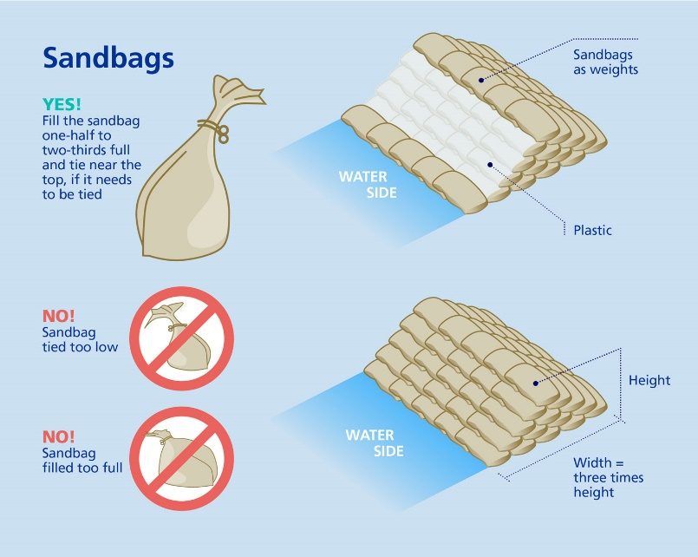

shelters
When disasters occur, the county provides safe refuge in three types of temporary emergency shelters: General Population Shelters, Pet Friendly Shelters and Special Needs Shelters.

Keep in mind, a shelter will not be a pleasant place. Oftentimes, they can be crowded, noisy, boring, short-staffed and have very little privacy. Hurricane shelters should be used only if you're ordered to evacuate and have nowhere else to go.

General Population Emergency Shelters
- Evacuation shelters will not have cots, blankets or food for residents.
- Bring water: one gallon per person, per day, Food: non-perishable, easy-to-prepare items, Bedding: pillows and blankets, Medications, medical items and supplies (hearing aids with extra batteries, glasses, contact lenses, syringes, etc.), Sanitation and personal hygiene items, Baby supplies (bottles, formula, baby food, diapers)
- If you have specific comfort needs (i.e. special dietary or snacks), plan to get those items ahead of time.
- Don't bring alcoholic beverages, illegal drugs, weapons
Pet Friendly Emergency Shelters

Hillsborough County offers eight (8) pet friendly shelters. To shelter your pet in case of emergency you must bring:
- Proof of current rabies vaccination and license for dogs and cats
- Pet must be on a leash or in a carrier
- A crate large enough for your pet to stand up and turn around. Cats need a crate large enough to contain litter and food/water
- Bring all pet supplies to include: crate, food, water, litter, treats, cleaning supplies, medicines, etc.
- You are responsible for the care of your pet while in the shelter
- Cohabitation of pets and owners is not permitted
If you are unable to meet these requirements, please make other arrangements to shelter your pet.
Special Needs Shelters

The County provides special needs shelters for residents whose medical condition may require the use of electrical equipment, oxygen, dialysis, or individuals with physical, cognitive, or medical conditions that may require assistance from medical professionals. Although special needs shelters provide more care than a general shelter, they DO NOT provide continuous bedside nursing, only assistance with daily functions and medical monitoring.
It is important to note that it is highly recommended you pre-register for the Special Needs Shelter Program before hurricane season. Register online at hillsboroughcounty.org or call the health department at 813-307-8063.

Note – More Comprehensive Lists for what to bring to emergency shelters can be found in the Hillsborough County Guide at www.kpmaster.com/disasterplanning.

hillsborough county alerts

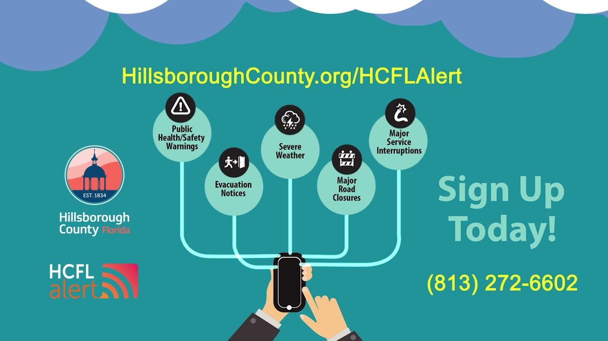

disaster radio services

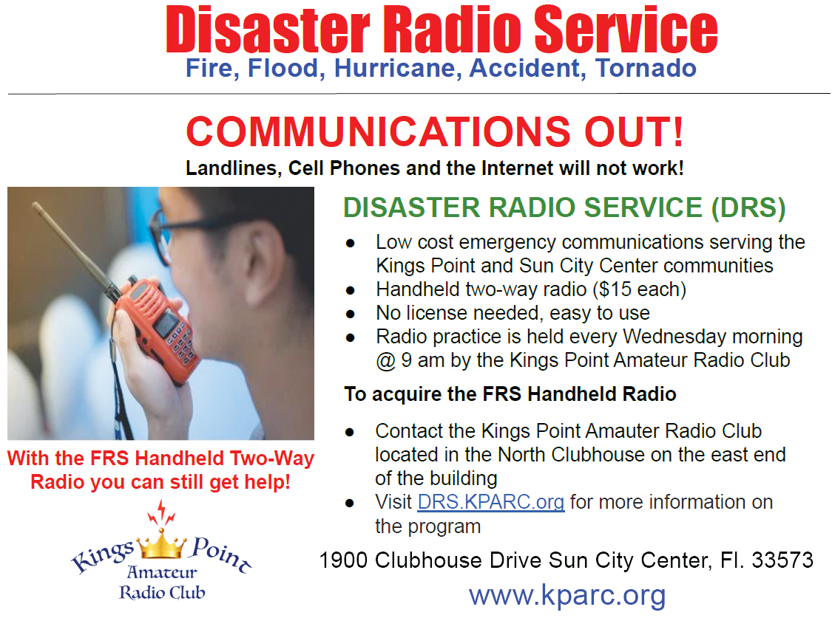

Resources – Important Phone Numbers
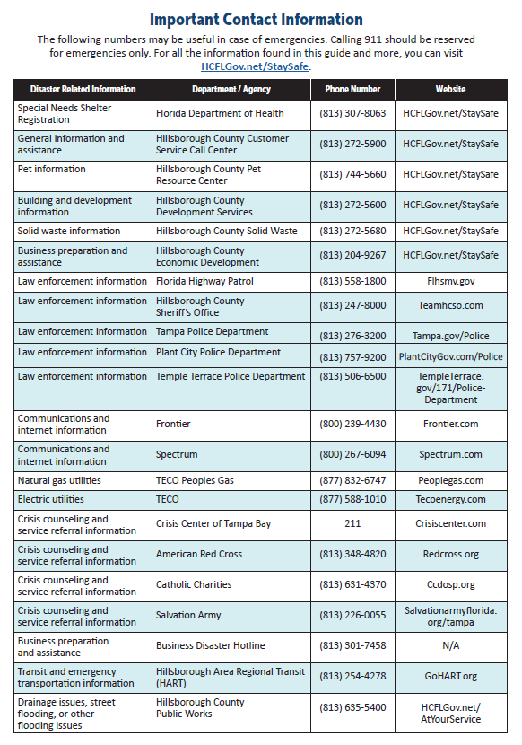

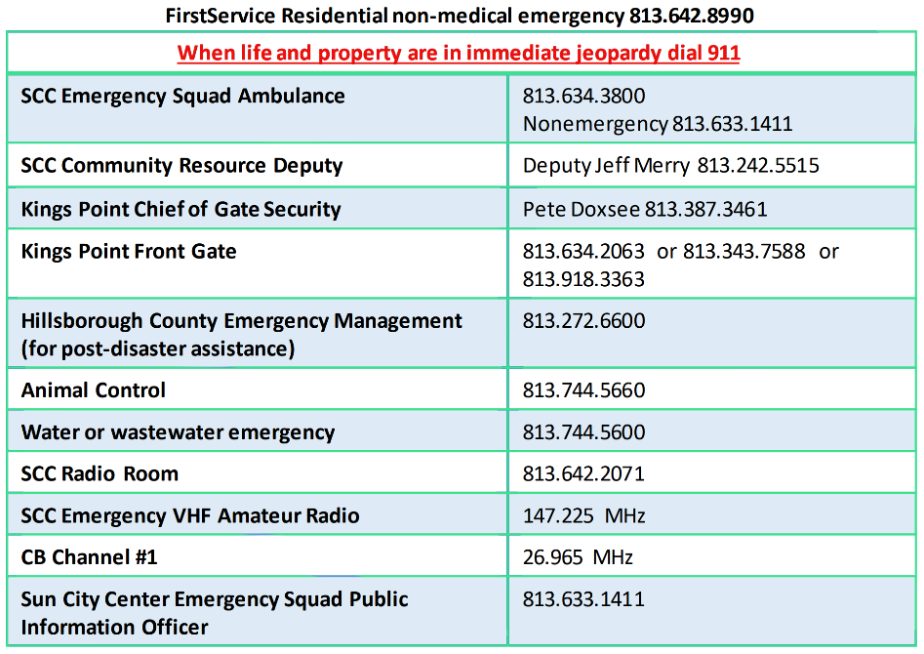

Resources – Association Emergency Plan Template

ASSOCIATION EMERGENCY PLAN CHECKLIST TEMPLATE

Board Member Name: ______________________
Title (Pre, VP, Sec, Treas.: ___________________
Address: _________________________________
Telephone number: _________________________
E-mail address: ____________________________

Approved by the Board of Directors on: ____________________________________________

DISASTER RISK ASSESSMENT
Outline past experience/s with disasters or emergencies. Pinpoint possible risks and potential effects the association may experience.
___________________________________________________________________________________________________________________________________________________________________________________________________________________________________________________________________________________________________
PLANNING
- Protecting Important Documents
Discuss how important documents such as the association’s governing documents, insurance policies, bank statements, minutes, contracts, warranties, etc. should be protected in case of emergencies.
___________________________________________________________________________________________________________________________________________________________________________________________________________________________________________________________________________________________________
- Financial Plan
Briefly discuss the budget for disaster and emergency expenses. Include funds for pre-disaster supplies and equipment, debris removal, demolition, uninsured losses, insurance deductibles, and other costs.
___________________________________________________________________________________________________________________________________________________________________________________________________________________________________________________________________________________________________
Person/s authorized to approve expenditures or contracts in times of disaster or emergency:
_______________________________________________________________________________________________

- Management Company Coordination
How should the association coordinate with its management company? Request the company to prepare in writing protocols in the event of an emergency or disaster. This includes communications, special support personnel, disaster management procedures, etc.
___________________________________________________________________________________________________________________________________________________________________________________________________________________________________________________________________________________________________

- Communications Plan
Discuss the communication methods the association will use before, during, and after the disaster or emergency. This can include the following:
- Assign a designated meeting place where residents can meet following a disaster.
- Create and distribute a disaster preparedness flyer.
- Dedicate a section of your community website for information on disaster preparedness.
- Maintain a directory containing resident contact information.
___________________________________________________________________________________________________________________________________________________________________________________________________________________________________________________________________________________________________

- Insurance Plan
Talk to your insurance provider about your coverage. Cover items such as deductibles, risks, and resident responsibilities. Find out what the procedures are for reporting losses. Keep a copy of insurance policies, along with vital contact information, in your emergency plan.
___________________________________________________________________________________________________________________________________________________________________________________________________________________________________________________________________________________________________
- Physical Plant Inventory
Maintain a record of all equipment and major items in common areas and community amenities. Include brand names, serial numbers, make and models, date of purchase, photos, and other pertinent information. It is also advisable to create a map showing the location of all switches and shut-off valves. Pictures/Drone footage of Roofs and the property surrounding your Association including additional buildings and structures.
___________________________________________________________________________________________________________________________________________________________________________________________________________________________________________________________________________________________________

- Evacuation Plan
Discuss the evacuation procedures for the community. Note - A lot of reference materials of Hillsborough County evacuation routes, maps, and packing lists for both the residents and pets, can be found at kpmaster.com/disasterplanning in the county guide
The plan must cover the following:
- Evacuation directions and routes (include maps)
- Nearest public shelters
- Special considerations for at-risk residents
- Remind residents to make arrangements for pet care and prepare pet supplies
___________________________________________________________________________________________________________________________________________________________________________________________________________________________________________________________________________________________________
RECOVERY
Take the following steps during the recovery procedure:
- Remain calm (panicking will only hinder your decision-making process)
- Secure the area
- Provide first aid to those who require it
- Cooperate with local authorities and follow their instructions
  - Do not allow residents to return to their properties without the go signal from local authorities (the Sherriff and the command center).
- Assess the damage
- Contact insurance provider
- Protect property – Notify FirstService about property issues
SAFETY PRECAUTIONS
It necessary for the association to take the following steps to prepare for a disaster or emergency:
- Educate residents on the emergency or disaster preparedness plan.
- Ask residents to review their individual insurance policies in case of an emergency or disaster.
- Provide an emergency contact person/s along with their phone number/s.
- Encourage residents to regularly inspect their property for safety hazards such as dead tree branches.
- Assign an area where residents can safely park their cars.
- Ask residents to keep their vehicles fueled prior to a forecasted calamity.
- Encourage residents to report any special needs they have (disabilities, medical, etc.) to the Board.
- Hand out maps with evacuation routes/directions and the nearest shelters.
- Encourage residents to arrange for pet care in case of an emergency.
- Prepare to have cash available.

EMERGENCY SUPPLIES CHECKLIST
Make note of the locations of all emergency supplies. Take inventory on a regular basis to determine what you lack. After a disaster, take inventory again and replace what has been exhausted.
☐ First aid supplies
☐ Painkillers such as ibuprofen, paracetamol, and aspirin
☐ Antihistamine (in cream and tablet form)
☐ Cough medicine
☐ Cold medicine
☐ Eye wash and bath
☐ Antiseptic cream
☐ Plasters in various sizes and shapes
☐ Sterile gauze dressings in various sizes
☐ At least two (2) sterile eye dressings
☐ Bandages
☐ Distilled water for washing wounds
☐ Alcohol-free cleansing wipes
☐ Safety pins
☐ Sticky tape
☐ Disposable sterile gloves
☐ Scissors
☐ Tweezers
☐ Thermometer
☐ Two-way radios
☐ Radios
☐ Flashlights
☐ Batteries
☐ Flares
☐ Bottled water
☐ Blankets
☐ Utility knives
☐ Rope and chain
☐ Duct tape
☐ Tarps
☐ Ladders
☐ Basics tools (hammer, shovel, nails, wrenches, etc.)
☐ Portable generators
☐ Portable heaters
☐ Fuel
☐ Digital cameras

EMERGENCY CONTACTS LIST
 | Name | Contact Number | Email
HOA/property manager
Board President
Board Vice President
Board Secretary
Board Treasurer
Disaster Committee Chair
Disaster Volunteer #1
Disaster Volunteer #2
Disaster Volunteer #3
Police Liaison
Fire Department Liaison
Power Company
Gas Company
Phone Company
Cable Company
Water/Sewage Company
Resident Physician
Resident Nurse
Insurance Agent
Contractor #1
Contractor #2
Contractor #3
Contractor #4
Contractor #5

RESIDENT CONTACT LIST
Maintain a resident directory consisting of their contact information and other details. Be sure to take note of the following:
- At-risk or elderly residents who require special treatment or medicine
- Residents with training, experience, or licenses in the medical field and public safety
- Residents with special equipment (trucks, 4WD, all-terrain vehicles, snowmobiles, small boats, generators, chainsaws, pumps, etc.)
Name | Contact Number | Email | Notes
Resident #1
Resident #2
Resident #3
Resident #4
Resident #5
Resident #6
Resident #7
Resident #8
Resident #9
Resident #10

Resources – Association Emergency Contact Form Template

Kings Point Association’s – Resident Emergency Information Form

This information will only be used by your Board of Directors in an EMERGENCY.

Association Name: ________________________

Owner Name/s: ___________________________________________________________

Unit Address: ____________________________ Unit #: ______ Sun City Center, FL. 33573

Please Check One: Are you a Unit Owner: ___________ or Unit Renter: ____________

Resident Status: Permanent: _____ Snowbird: _____ Live alone: ______ Assistance: ______

Owner 1 Cell/House Phone #: ______________ E-mail Address: ______________________

Owner 2 Cell/House Phone #: ______________ E-mail Address: ______________________

Do you plan to shelter in place or evacuate in the event of a disaster: __________________

If you choose to shelter in place, do you require special items such as oxygen, medication, or have caregivers helping you on a daily basis that we need to know about? If yes, please describe:

Do you have pets? (If yes, Describe:) _____________________________________________________________________________

In your absence, if an EMERGENCY occurs, who should your Association contact?

- Name: __________________________ Address: _______________________________

Phone: __________________________ E-mail: ________________________________

- Name: __________________________ Address: _______________________________

Phone: __________________________ E-mail: ________________________________

Signature/s: #1_______________________ / _______ #2________________ / ___________

Resources – Association Emergency Plan Check List

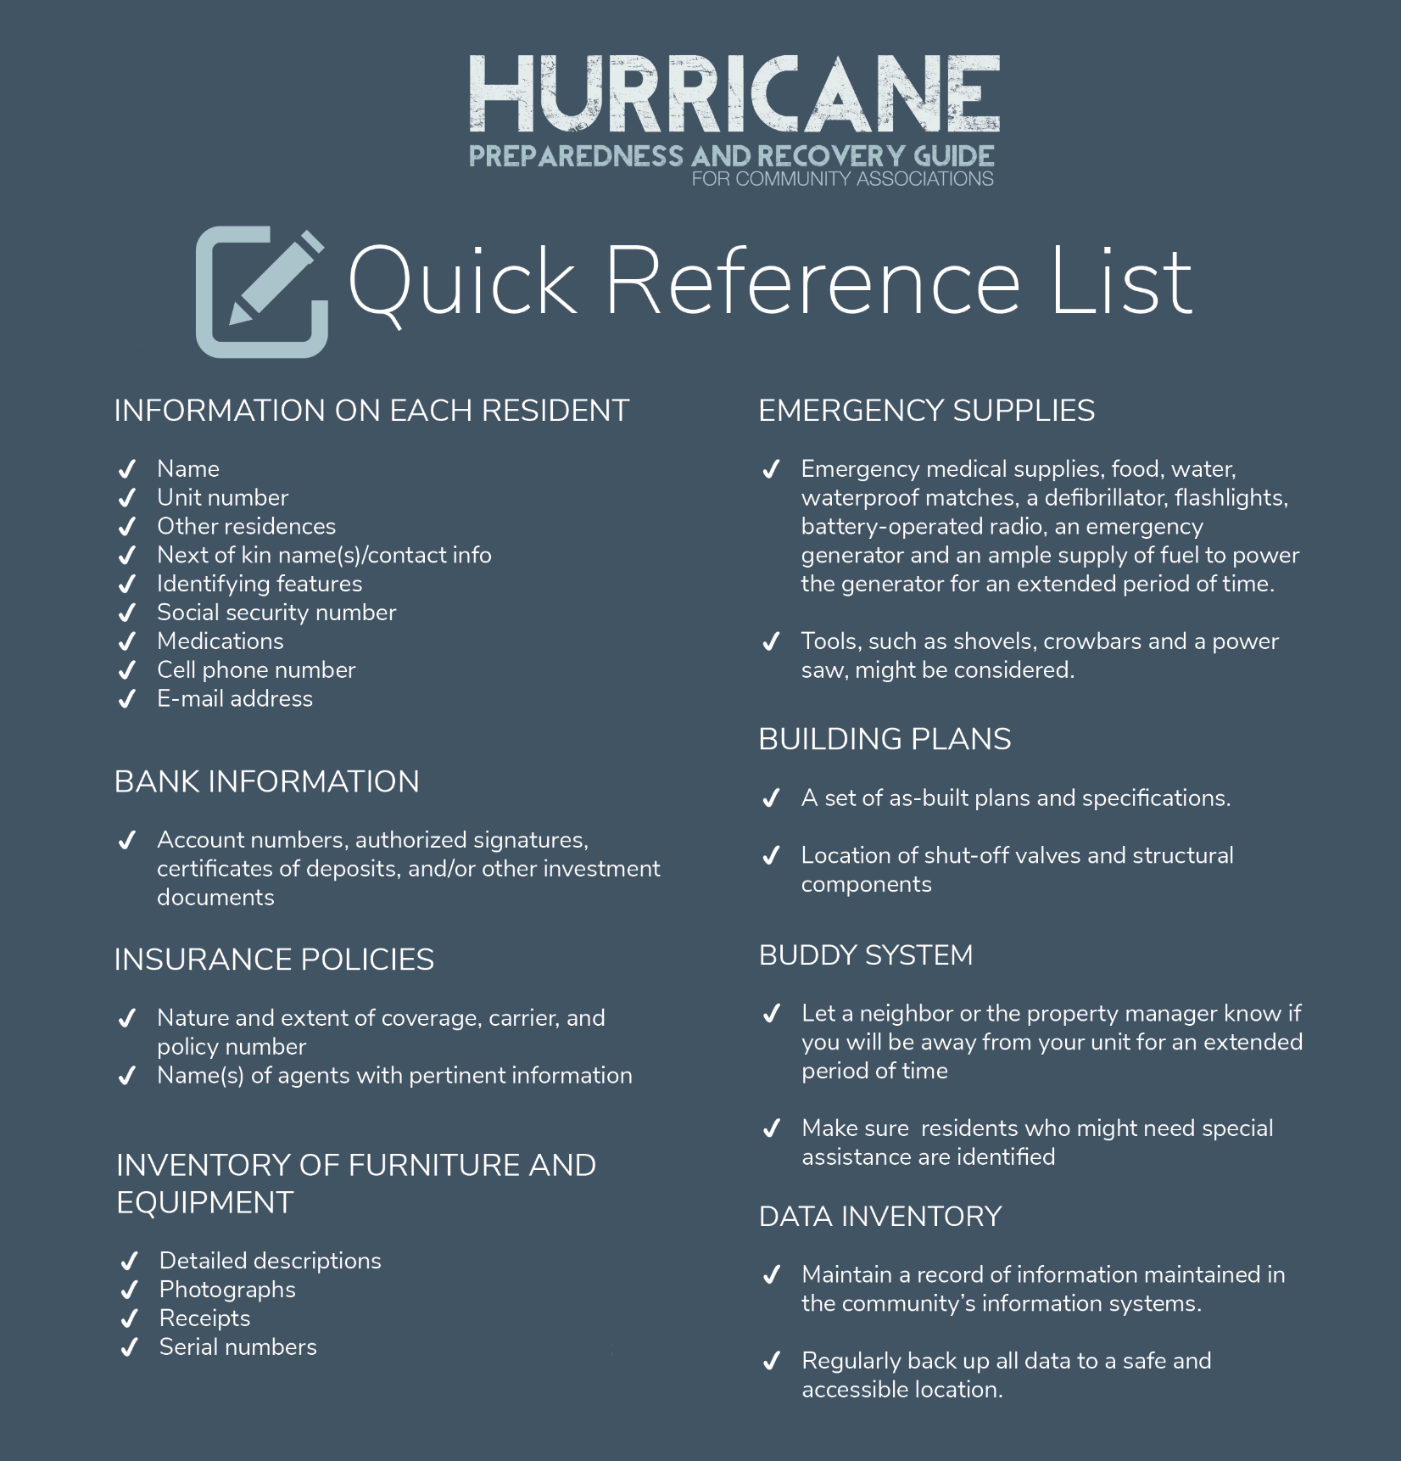

Resources – Disaster Kit Checklist

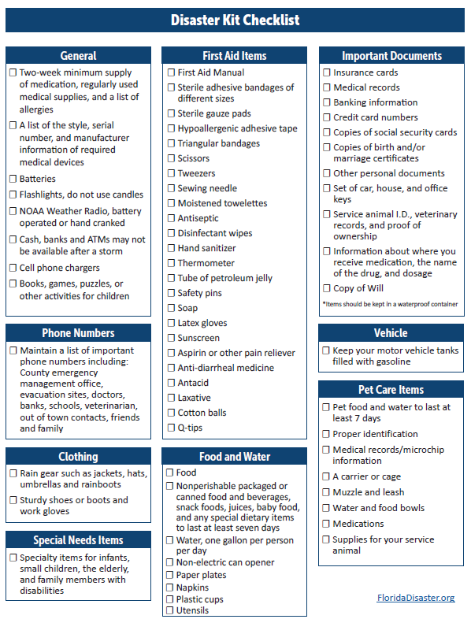

Resources – Special Needs Shelter Form
